Sean Yang

Pd 4

12/5/18

Journal report 11

I had a lot of misdetections with tilted faces. My solution was to rotate the points around the center of the face to adjust for the tilt. I used two reference points and the law of cos to calculate the face’s tilt from the vertical. Initially, I accidentally used atan instead of acos and didn’t realize it. I figured out the issue by printing out the angles from the vertical and found that some of the angles were too small. I fixed the problem and the tilt adjustment is functional. The image below shows an example of tilt adjustment. The lines overlaid on image shows the adjusted key points. The accuracy of the tilted face gesture detection is better, but it’s still not reliable. The detector works perfectly for small tilts. Since the angle adjustment is fairly basic, it doesn’t adjust the tilt perfectly. So, when the head is tilted by a lot, the detector is not too accurate. Although there are still problems, I’m satisfied with the improvement. It’s able to eliminate the errors of classifying neutral as a gesture when the head is tilted.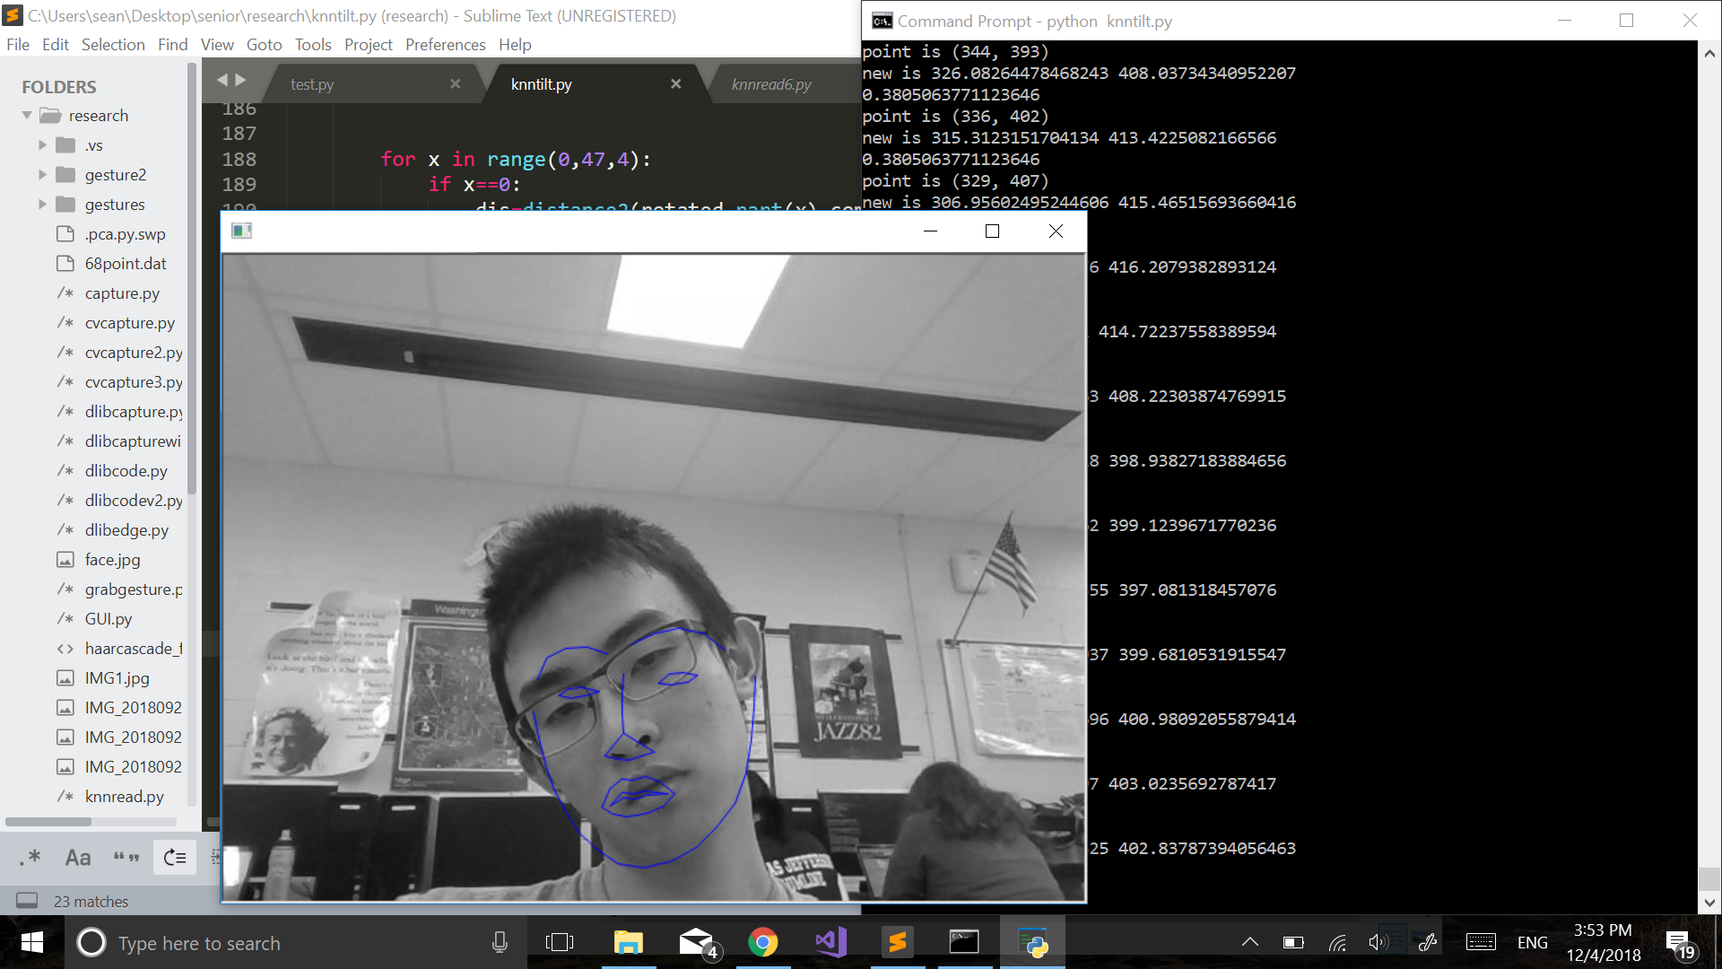

I also looked into the making a web demo of my project. I am planning to use Flask, a python web framework because I saw a blog post about using Flask to live stream via webcam (<https://blog.miguelgrinberg.com/post/video-streaming-with-flask>). The web demo definitely seems to be possible. However, I’m not too familiar with web development. It will take some time for me to figure out how to implement the web demo.